Iamb

🔹 What is Iamb
# Source: Chatgpt (GPT-4-turbo) at [8/3/2025]
An iamb is a metrical foot consisting of two syllables:
- The first syllable is unstressed, and the second is stressed:
◡ —
This rising rhythm creates a natural, flowing sound that closely mirrors spoken English.

✅ Syllable Pattern:
# Source: Chatgpt (GPT-4-turbo) at [8/3/2025]
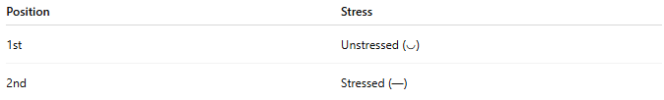
Position | Stress
1st | Unstressed (◡)
2nd | Stressed (—)

✅ Examples of Iambic Words or Phrases:
# Source: Chatgpt (GPT-4-turbo) at [8/3/2025]
- aWAY
- beLONG
- aSIDE
- to NIGHT
- the SUN
These follow the unstressed–stressed pattern naturally when spoken aloud.

✅ Function in Poetry:
# Source: Chatgpt (GPT-4-turbo) at [8/3/2025]
The iamb is the most common metrical foot in English poetry and forms the basis of many metrical patterns:
- Iambic pentameter (5 iambs per line)
- Iambic tetrameter (4 iambs per line)
- etc.

✅ Example Line (Iambic Pentameter):
# Source: Chatgpt (GPT-4-turbo) at [8/3/2025]
Shall I / comPARE / thee TO / a SUM / mer’s DAY?
Each of the five metrical feet here is an iamb.

✅ Contrast with Other Feet:
# Source: Chatgpt (GPT-4-turbo) at [8/3/2025]
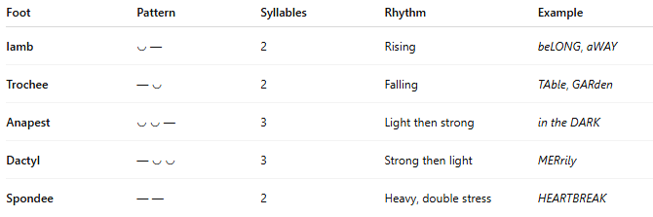
Foot | Pattern | Syllables | Rhythm | Example
Iamb | ◡ — | 2 | Rising | beLONG, aWAY
Trochee | — ◡ | 2 | Falling | TAble, GARden
Anapest | ◡ ◡ — | 3 | Light then strong | in the DARK
Dactyl | — ◡ ◡ | 3 | Strong then light | MERrily
Spondee | — — | 2 | Heavy, double stress | HEARTBREAK

🔍 Summary:
# Source: Chatgpt (GPT-4-turbo) at [8/3/2025]
- Iamb = one unstressed + one stressed syllable (◡ —)
- Found throughout English verse
- Builds natural rhythm
- Most famous for use in iambic pentameter, the meter of Shakespeare and many classical poets

